

Assessment Cover Page
Student Full Name | Aoife Kennedy
Student Number | sba26209
Module Title | Strategic Thinking
Assessment Title | CA1 Capstone Project Proposal
Lecturer/Supervisor | Taufique Ahmed
Assessment Due Date | 25/10/2026
Date of Submission | 25/10/2026
Use of AI Tools

I acknowledge the use of Microsoft CoPilot for the purpose of checking grammar, improving sentence structure, enhancing the clarity and readability of the report, and condense paragraphs where necessary to help meet the 1,500-word requirement. AI was used as a writing support tool and was not used to complete the assessment independently or make final project decisions.
Declaration
By submitting this assessment, I confirm that I have read the CCT policy on academic misconduct and understand the implications of submitting work that is not my own or does not appropriately reference material taken from a third party or other source.
I declare it to be my own work and that all material from third parties has been appropriately referenced.
I further confirm that this work has not previously been submitted for assessment by myself or someone else in CCT College Dublin or any other higher education institution.

Predictive Analytics for Proactive Order Fulfilment Risk Management

Table of Contents

1.Introduction 1
2. Problem Definition 2
3. Aim and Objectives 2
4. Scope 3
5. Methodology 3
6. Data Sources 5
7. Technologies and Tools 5
8. Expected Deliverables 6
9. Project Timeline 6
10. Ethical and Legal Considerations 7
11. Conclusion 7
References 7

1.Introduction
Order fulfilment is an important part of supply-chain operations. When orders are delayed, customer satisfaction can be affected and additional pressure may be placed on delivery management teams. Identifying orders that are likely to be delayed in advance would enable fulfilment teams to investigate potential issues earlier and take appropriate action where necessary.
I chose this project because it relates to my current role as an IT Product Manager supporting Supply Chain Fulfilment. Working with both business and technology teams has given me an interest in how data can be used to improve processes and help people make better decisions. Recent research suggests that predictive analytics and data analytics tools can play a significant role in improving supply-chain performance and supporting data-driven decision-making for continuous improvement (Sy, 2025). I also see this project as an opportunity to put what I have learned during the Higher Diploma in Data Analytics for Business into practice.
The project will use historical supply-chain data to investigate whether machine learning can help predict which orders are at risk of late delivery. I want to find out whether the data contains useful patterns that could help identify potential delays earlier, rather than relying only on manual checks or waiting until an order is already late.

2. Problem Definition
Late deliveries can happen for different reasons, such as the type of product ordered, the shipping method and where the order is being delivered. I want to find out if looking at this information can help identify which orders might arrive late, giving fulfilment teams more time to look into potential problems.
By comparing different machine learning models, I hope to find out whether historical order and shipping information can help identify orders that may be delayed. I will then look at how the results could be useful to fulfilment teams when deciding which orders may need further attention.

3. Aim and Objectives

Aim
The aim of this project is to develop and evaluate machine learning classification models to predict late-delivery risk using historical supply-chain data.
The project will examine which variables are useful for making predictions and compare different models to see which performs best.

Objectives
The main objectives are:
- Collect, clean and prepare the dataset for analysis.
- Explore the data to identify patterns relating to late deliveries.
- Select and create suitable variables for predicting late-delivery risk.
- Develop and compare different machine learning classification models.
- Evaluate the models using appropriate performance measures.

Business Objective
The business objective is to investigate whether predictive analytics could help fulfilment teams identify potentially delayed orders earlier and prioritise which orders may need further investigation.

4. Scope
This project will use historical supply-chain data to predict late-delivery risk based on order, product, geographical and shipping characteristics. It will include data preparation, exploratory analysis, feature engineering, development and evaluation of Logistic Regression, Decision Tree and Random Forest models, and recommendations based on the findings.
The project will focus on predicting whether an order is at risk of late delivery. It will exclude exact delivery-time prediction, investigation of individual delay causes, warehouse and inventory optimisation, delivery route and carrier allocation optimisation, and financial forecasting. The analysis will use historical data rather than real-time order tracking.

5. Methodology

Phase 1: Data Collection
Historical supply-chain data will be obtained from the DataCo SMART SUPPLY CHAIN FOR BIG DATA ANALYSIS dataset, available at https://doi.org/10.17632/8gx2fvg2k6.5.

Phase 2: Data Preparation
Python will be used to clean and prepare the dataset. Tasks will include:
- Renaming columns where needed
- Removing unnecessary variables
- Handling missing values and duplicates
- Correcting data types and inconsistencies
- Removing unnecessary personal information

Phase 3: Exploratory Data Analysis
Exploratory data analysis will be used to identify patterns and relationships associated with late deliveries. This will include:
- Late-delivery risk distribution
- Shipping mode analysis
- Product category and market comparisons
- Customer segment and order quantity analysis
Charts and visualisations will help identify useful patterns and potential predictors.

Phase 4: Feature Engineering
Relevant variables will be selected and transformed to improve model performance. New features, such as order month or day of the week, may also be created to test if it will improve performance.

Phase 5: Machine Learning Models
The following classification algorithms will be developed and compared:
- Logistic Regression
- Decision Tree
- Random Forest
Logistic Regression will be used as the baseline classification model. Decision Tree will be used because it can identify non-linear relationships and interactions between variables. Random Forest will be used because ensemble learning methods often provide improved predictive performance and reduced overfitting compared to individual decision trees (Jain, 2024).
The dataset will be divided into training and testing sets to evaluate model performance on unseen data.

Phase 6: Model Evaluation
The models will be evaluated and compared using the following metrics:
- Accuracy.
- Precision.
- Recall.
- F1-score.
- Confusion matrix.
Particular attention will be given to recall, as identifying orders at risk of late delivery is a key objective.

Phase 7: Visualisation and Recommendations
The final stage will present the results through charts, model comparisons and an evaluation of important variables. Recommendations will be made on how the findings could support fulfilment planning and help identify potentially late deliveries.

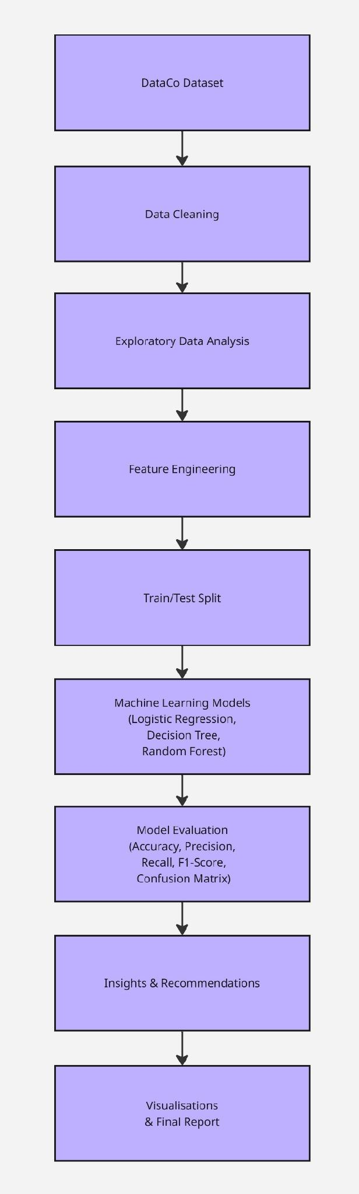
Architectural Diagram created on Miro.com

6. Data Sources
The dataset selected for this project is DataCo SMART SUPPLY CHAIN FOR BIG DATA ANALYSIS, obtained from Mendeley Data (Constante, Silva and Pereira, 2019). It contains approximately 180,500 order records and 53 variables covering supply-chain information such as order details, product categories, customer segments, shipping methods and delivery outcomes.
Dataset link: https://data.mendeley.com/datasets/8gx2fvg2k6/5
The dataset is suitable for this project because it provides information that can be analysed to investigate patterns associated with late deliveries. The Late_delivery_risk variable will be used as the target for the classification models, while relevant order, product, geographical and shipping variables will be considered as potential predictors. The data will be cleaned and prepared before analysis, with unnecessary identifying information removed and variables that could cause data leakage excluded.

7. Technologies and Tools
The following tools will be used throughout the project:
- Python: Main programming language.
- Pandas and NumPy: Data cleaning and preparation.
- Matplotlib and Seaborn: Data visualisation and exploratory analysis.
- Scikit-learn: Machine learning model development and evaluation.
- Jupyter Notebook: Analysis and documentation.

8. Expected Deliverables
By the end of the project, I expect to have completed the following:

Data Preparation
A cleaned dataset with unnecessary columns removed and any data-quality issues documented.

Exploratory Data Analysis
An analysis of the dataset showing patterns and relationships that may help explain late-delivery risk.

Predictive Features
A set of selected variables suitable for training the classification models, with attention given to avoiding data leakage.

Machine Learning Models
Three classification models developed using Logistic Regression, Decision Tree and Random Forest.

Model Evaluation
A comparison of the models using accuracy, precision, recall, F1-score and confusion matrices.

Final Report
A report explaining the business problem, the dataset, the methodology, the modelling process, the results and the main conclusions.

Visual Presentation
Charts or a Power BI dashboard, where appropriate, to present the findings in a clear and understandable way.
The final outcome should provide a clearer understanding of whether historical supply-chain data can help identify orders that may be at risk of late delivery.

9. Project Timeline
The project will run from October to May across two semesters. Semester 1 will focus on the proposal, data collection and preparation, exploratory analysis and feature engineering. Semester 2 will cover model development, evaluation, interpretation and visualisation.
The final stage will focus on interpreting the results, preparing any visualisations and completing the project report and presentation.
The timeline may need to be adjusted as the project progresses, especially if the dataset requires more preparation than expected or if changes are needed to the modelling approach.
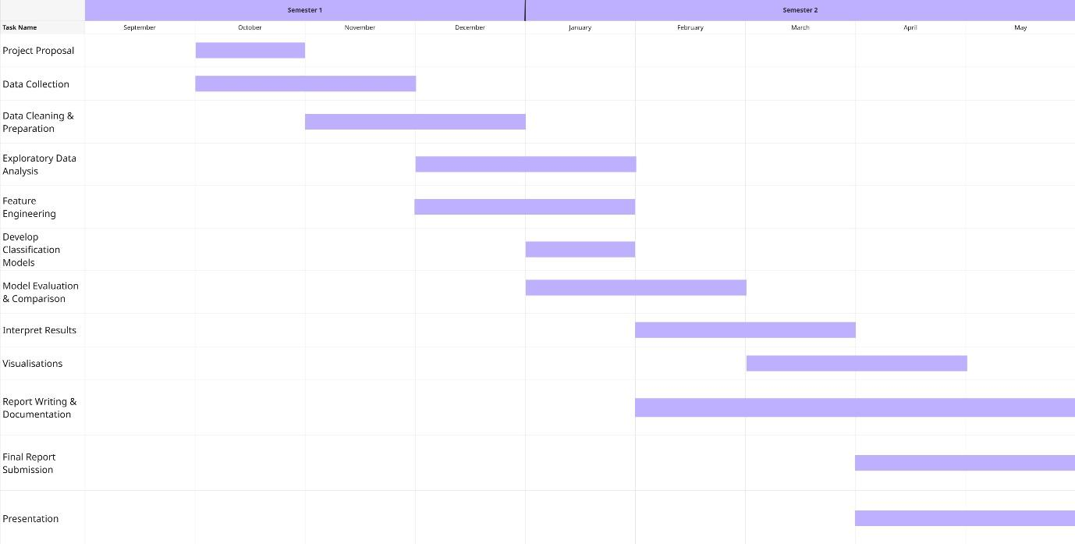
Gantt Chart created on Miro.com

Milestone | Target Month
Proposal | October
Data Prepared | December
Features Finalised | January
Models Complete | March
Evaluation Complete | April
Submission | April/ May

10. Ethical and Legal Considerations
The DataCo dataset is available under the Creative Commons Attribution 4.0 International (CC BY 4.0) licence (Creative Commons, 2024). I will acknowledge the dataset source and authors appropriately. As the dataset contains customer-related information, unnecessary identifiers, such as names, email addresses and street addresses will be removed, and only relevant variables will be retained. The data will be stored securely, and identifying information will not be included in the final report or presentation. I will consider relevant GDPR and Irish data-protection requirements and follow CCT College Dublin's ethics procedures, including confirming whether additional approval is required.

11. Conclusion
I chose this project because it gives me an opportunity to apply what I have learned during the Higher Diploma in Data Analytics for Business to an area that is relevant to my current role in supply-chain fulfilment.
Using the DataCo dataset, I will investigate whether historical order and shipping information can be used to predict late-delivery risk. I will clean and explore the data, select suitable variables, develop classification models and compare their performance.
The project will produce a proof of concept and recommendations based on the results. Ultimately, I want to establish whether machine learning could help identify potentially delayed orders earlier and provide useful information to support fulfilment teams in their day-to-day work.

References
- Constante, F., Silva, F. and Pereira, A. (2019) DataCo SMART SUPPLY CHAIN FOR BIG DATA ANALYSIS. Mendeley Data, Version 5. Available at: https://doi.org/10.17632/8gx2fvg2k6.5
- CCT College Dublin (2026) Strategic Thinking Module Notes. Available at https://moodle.cct.ie/course/view.php?id=3679 [moodle.cct.ie]
- CCT College Dublin (2026) Data Preparation Module Notes. Available at https://moodle.cct.ie/course/view.php?id=3680 [moodle.cct.ie]
- CCT College Dublin (2026) Statistical Techniques Module Notes. Available at https://moodle.cct.ie/course/view.php?id=3681 [moodle.cct.ie]
- CCT College Dublin (2026) Machine Learning Module Notes. Available at https://moodle.cct.ie/course/view.php?id=3682 [moodle.cct.ie]
- Creative Commons (2025) Attribution 4.0 International (CC BY 4.0). Available at: https://creativecommons.org/licenses/by/4.0/
- Jain, P. (2024) ‘Predicting Delivery Outcomes in Supply Chain Management Using Machine Learning: A Random Forest Classifier Approach’. Available at DOI:10.58257/IJPREMS36629
- Microsoft. (2026). Copilot [Large language model]. https://copilot.microsoft.com
- Sy, M.J.A. (2025) 'Logistics Performance, Supply Chain Resilience, Integrated Information System, and Performance Metrics as Correlates of Supply Chain Performance of the Downstream Integration: A Literature Review', Open Journal of Business and Management. Available at: https://doi.org/10.4236/ojbm.2025.134121

